Table of Contents

Introduction 2

System design 2

Database design 2

System implementation 3

Testing 3

Create function 3

Edit function 6

Delete function 7

Responsiveness 7

Conclusion 8

# Links

Assignment 3: <https://30034065.2020.labnet.nz/comp5210/assign3/index.php>

# Introduction

In this document, we will lay down the procedure we have taken to complete this project. To come up with a successful project, we had to follow the software development life cycle. The first cycle is to do the system analysis. This cycle is carried in order to identify the goals, purposes, and create development procedure that will achieve them in efficient way. The second phase is to identify all requirements of the system. The design phase is concern with how the system will look and feel to the user. We identified the interface, theme, primary colors and the content required by developers. The fourth stage is the development phase where the system ideas are implemented. The developer will use HTML and PHP and MySQL database to develop the system. The final phase is testing where the system is tested to measure if the goals were achieved.

# System design

System design include the design of the interface and the database. The database will be designed using PHPMyAdmin in XAMPP. The user interface will be designed using HTML and CSS. We will use bootstrap to add responsiveness to the site.

## Database design

|  |  |  |
| --- | --- | --- |
| SCP table | | |
| item | Varchar(15) | Primary key, not null |
| Object class | Varchar(15) | Not null |
| SCP | text |  |
| Description | text |  |

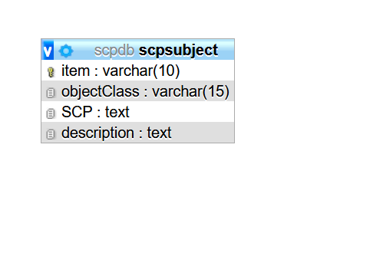

The website will have two main section, the navigation and the body. The navigation will be positioned at the top of the screen.

# System implementation

The system was developed using PHP, MySQL, HTML and Bootstrap. Html is a markup language and is used to render content into web browser. HTML make use of tags ad element in rendering the content. PHP was used as a scripting language to communicate between the database and the server. Bootstrap was used to make the website to have a responsive behavior.

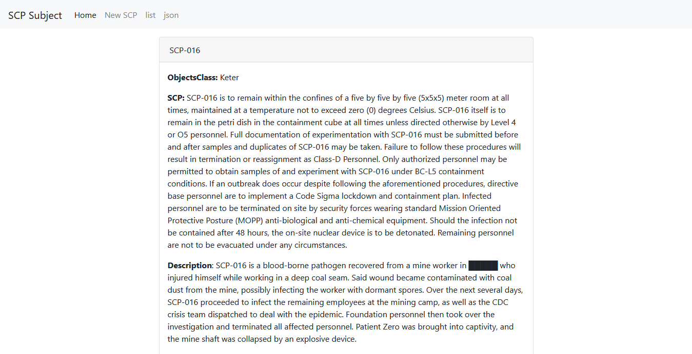

Figure . . . . . . . . . . . . . . . . . . . . . . . . . . . . . . . . . . . . . . . . . . . . . . . . . . . . . . . . . . . . . . . . . . . . . . . interface

# Testing

We will test functional and non-functional requirement of the system. Functional requirements is mainly concerned with how the system is functioning.

## Create function

The first component to build in the system is the create function. The create function will add the data into the database. We will create a new SCP by adding the item number, the object class, and the description of the scp.

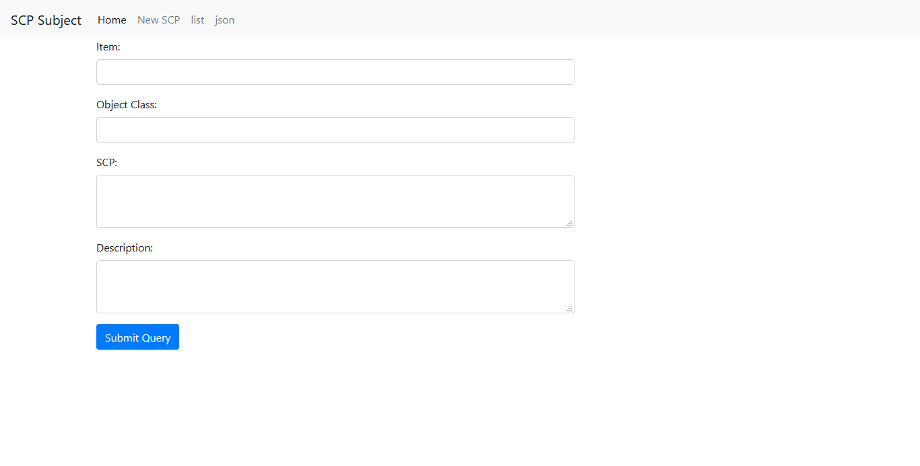

Figure . . . . . . . . . . . . . . . . . . . . . . . . . . . . . . . . . . . . . interface for adding new data to the system.

All data will be displayed on the home page. Each data will display the item number, the object class and the description. Below is the screen shot of the first page.

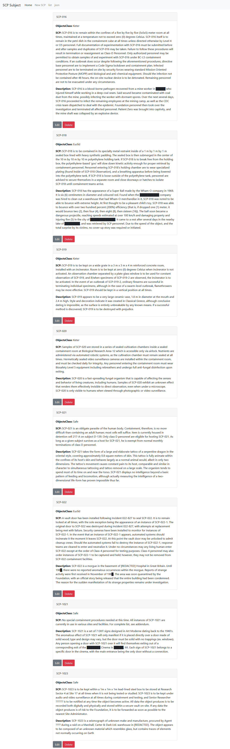

Each item has a delete and edit button. Which redirect user to the respective page.

## Edit function

When the edit button is clicked the user will be redirected to an edit page with a form to edit the current data.

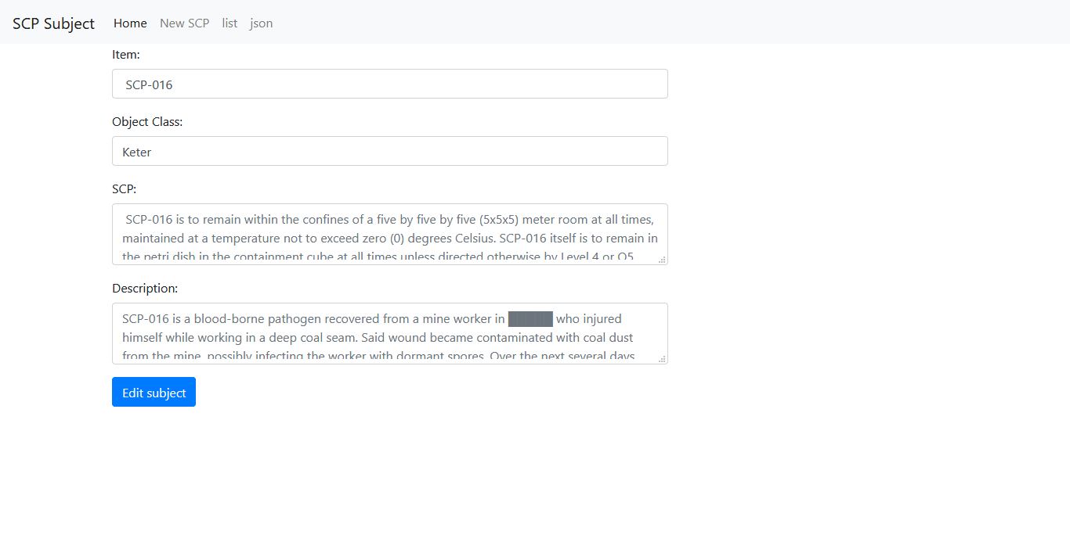

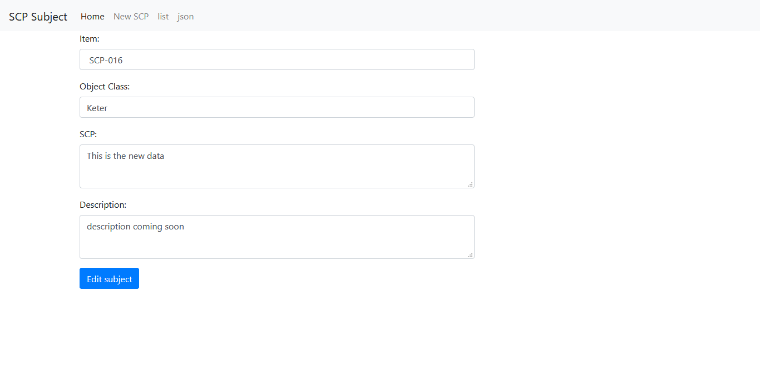

Clicking the edit subject button will return a success message.

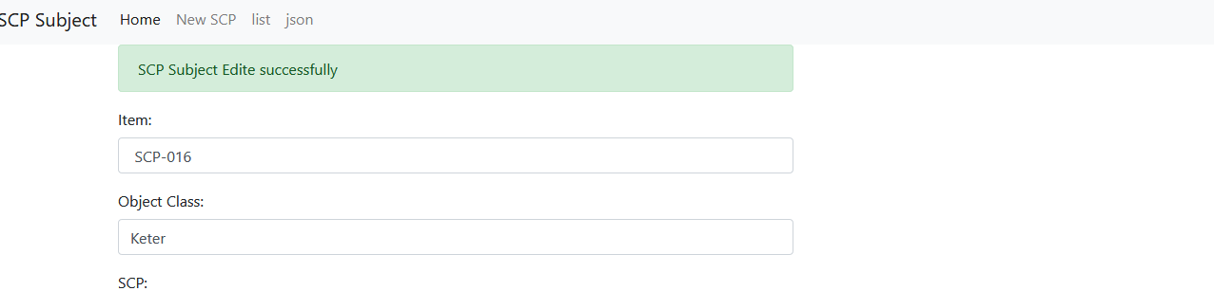

Figure . . . . . . . . . . . . . . . . . . . . . . . . . . . . . . . . . . . . . . . . . . . . . . . . . . . . . . . . . . . . . . . . . . . . . . . . . . . . . the success message after editing the data

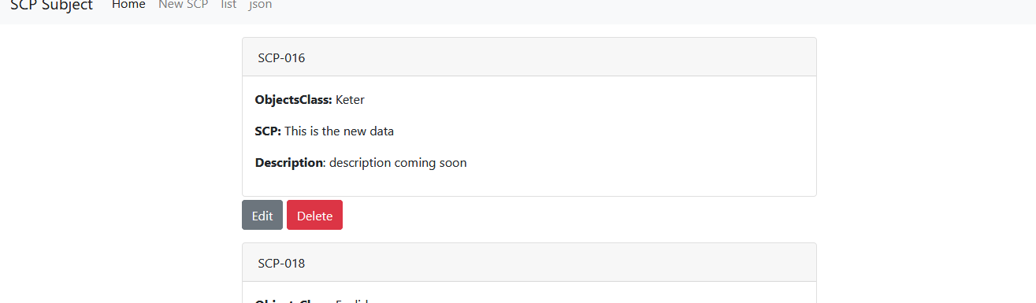

Figure . . . . . . . . . . . . . . . . . . . . . . . . . . . . . . . . . . . . . . . . . . . . . . . . . . . . . . . . . . . . . . . . . . . . . . . . the data after editing

## Delete function

To delete an item from the database and the system we will use the delete button.

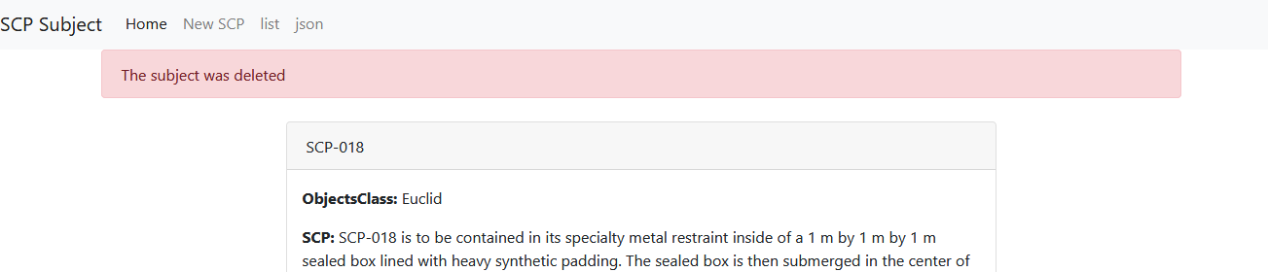

Figure . . . . . . . . . . . . . . . . . . . . . . . . . . . . . . . . . . . . . . . . . . . . . . . . . . . . . . . . . . . Delete message after deleting an item

## Responsiveness

Next step is to test the responsiveness of the system. We will test how the system will behave when opened using different screen. On a large screen (desktop, laptop) the navigation will be fully displayed. On a small screen the navigation will collapse and a menu icon will appear at the left top side of the website. Clicking the menu icon will toggle the navigation it will be displayed vertically.

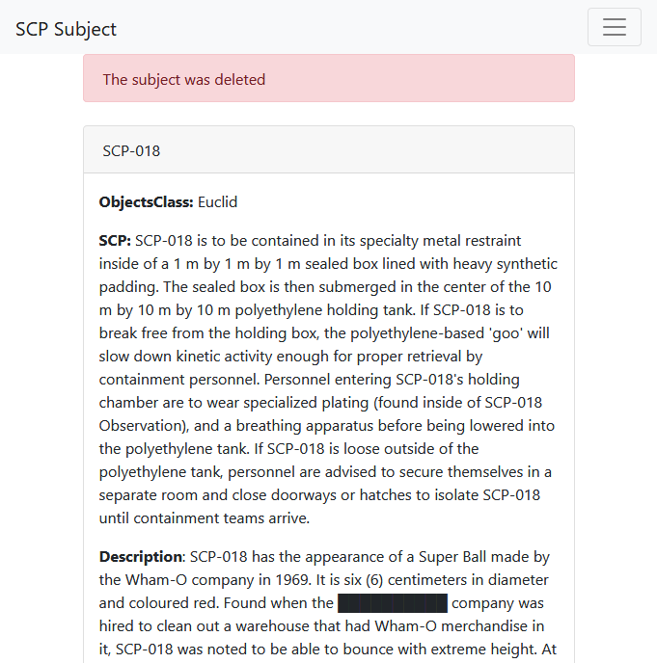

Figure . . . . . . . . . . . . . . . . . . . . . . . . . . . . . . . . . . . . . . . . . . . . . . . . . . . . . . . . . .The navigation view on a small screen

# Conclusion

In the document we have covered the process used in completing the system. We have tested the system and all functionality got a pass. The website has different view when viewed on different screen.